**PRACTICAL – 07**

**AIM:**

Implementation and analysis of Linear Regression through Graphical Methods.

**THEORY:**

* Linear regression is used for finding linear relationship between target and one or more predictors. There are two types of linear regression- Simple and Multiple.
* Linear regression is useful for finding relationship between two continuous variables. One is predictor or independent variable and other is response or dependent variable. It looks for statistical relationship but not deterministic relationship.
* Relationship between two variables is said to be deterministic if one variable can be accurately expressed by the other. For example, using temperature in degree Celsius it is possible to accurately predict Fahrenheit.
* Statistical relationship is not accurate in determining relationship between two variables. For example, relationship between height and weight.
* The core idea is to obtain a line that best fits the data. The best fit line is the one for which total prediction error (all data points) are as small as possible. Error is the distance between the point to the regression line.

**Y(pred) = b0 + b1*x**

The values b0 and b1 must be chosen so that they minimize the error. If sum of squared error is taken as a metric to evaluate the model, then goal to obtain a line that best reduces the error.

**Error Calculation**

Image

If we don’t square the error, then positive and negative point will cancel out each other.

For model with one predictor,

**Intercept Calculation:**

Image

**Coefficient Formula:**

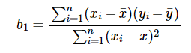

**CODE & OUTPUT:**

1. **SIMPLE LINEAR REGRESSION:**

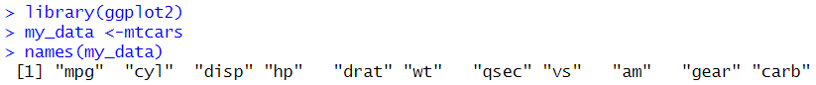

1. **PRINTING DIMENSIONS OF DATASET:**



1. **CREATING RANDOM SAMPLE:**Text, letter

   Description automatically generated
2. **CREATING TRAINING & TESTING DATASET:**

1. **CREATING LINEAR REGRESSION MODEL AND PRINTING RESULTS:**Text, letter

   Description automatically generatedText

   Description automatically generated
2. **CALCULATE CORRELATION:**



1. **PLOTTING POINTS:**

1. **PLOTTING LINEAR REGRESSION GRAPH:**Chart, scatter chart

   Description automatically generated
2. **MULTI LINEAR REGRESSION:**
3. **CREATING MULTI LINEAR REGRESSION MODEL & PRINTING SUMMARY:**Table

   Description automatically generated

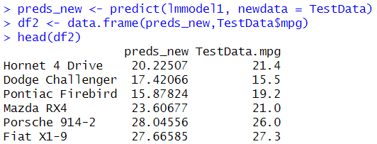

1. **PLOTTING MULTI LINEAR REGRESSION GRAPH:**

**CONCLUSION:**

In this practical I learnt the implementation of linear regression in R.